Social Media Tool Kit – Mass HAF – June 2022
Suggested Platforms: Twitter, Instagram, Facebook
All posts should link to www.massmortgagehelp.org
Copy | Image
Suggested Copy | Suggested Image
Are you three or more months behind on your mortgage payments? The Massachusetts Assistance Fund (Mass HAF) can give you relief for overdue payments. Find out if you qualify by visiting massmortgagehelp.org today.  #HomeownerAssistanceFund #mortgagehelp #mortgagerelief #mortgageassistance | 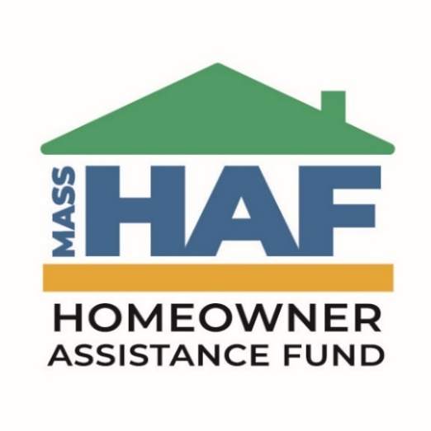
The Massachusetts Homeowner Assistance Fund (Mass HAF) has helped many homeowners with an overdue mortgage. Find out if Mass HAF can help you!  #HomeownerAssistanceFund #mortgagehelp #mortgagerelief #mortgageassistance  www.massmortgagehelp.org | 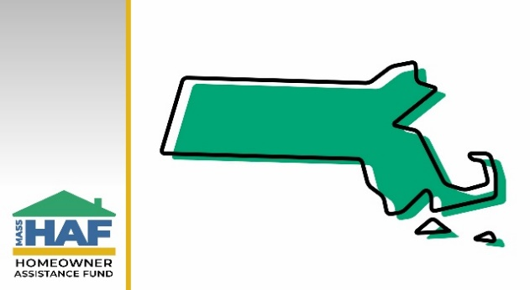
The Massachusetts Homeowner Assistance Fund (Mass HAF) has helped over 100 homeowners in the Springfield area. How can Mass HAF help you?  Visit massmortgagehelp.org.  #HomeownerAssistanceFund #mortgagehelp #mortgagerelief #mortgageassistance | 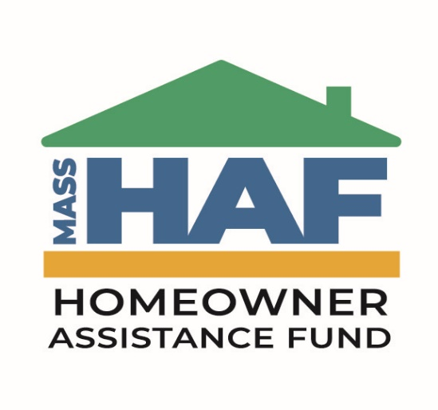
Thanks to Mass HAF, over 40 homeowners in Boston have received assistance for their overdue mortgage after being impacted by the pandemic. See if your family qualifies today.  #HomeownerAssistanceFund #mortgagehelp #mortgagerelief #mortgageassistance  www.massmortgagehelp.org | 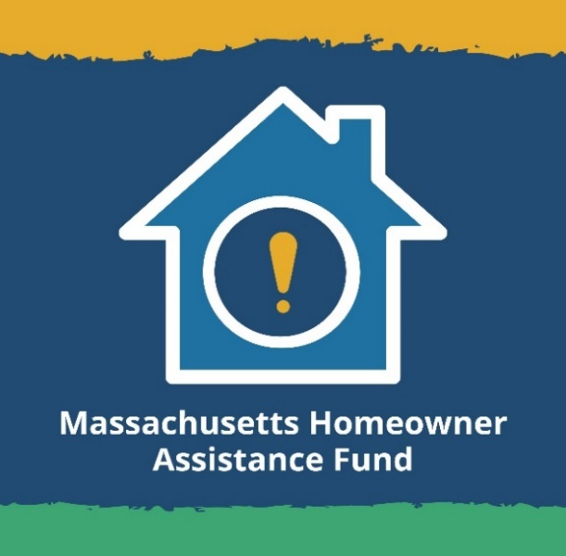
The COVID-19 pandemic has been hard on a lot of us financially. If you are behind on your mortgage by three months or more, Mass HAF is here to help. Visit the link below to see if you qualify.  #HomeownerAssistanceFund #mortgagehelp #mortgagerelief #mortgageassistance  www.massmortgagehelp.org | 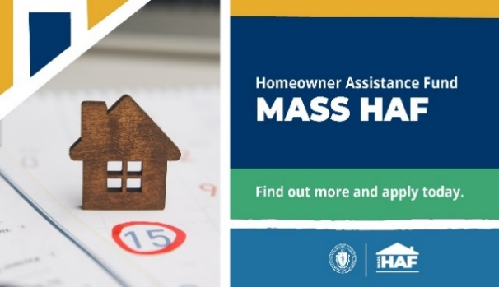
The Massachusetts Homeowner Assistance Fund (Mass HAF) has helped almost 700 homeowners avoid foreclosure! Learn about Mass HAF today.  #HomeownerAssistanceFund #mortgagehelp #mortgagerelief #mortgageassistance  www.massmortgagehelp.org | 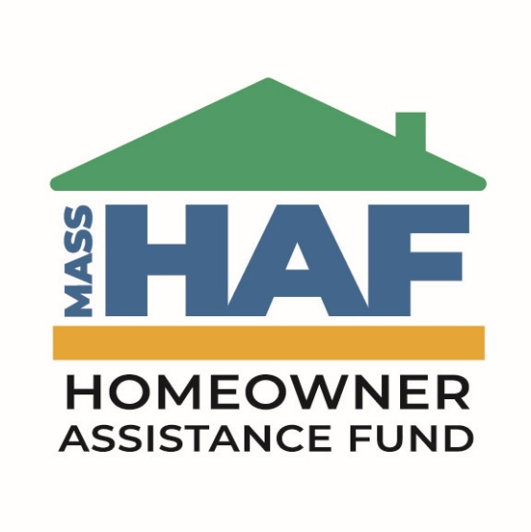
The Massachusetts Homeowner Assistance Fund (Mass HAF) is still accepting applications. Get the help you need and apply today.  #HomeownerAssistanceFund #mortgagehelp #mortgagerelief #mortgageassistance  www.massmortgagehelp.org | 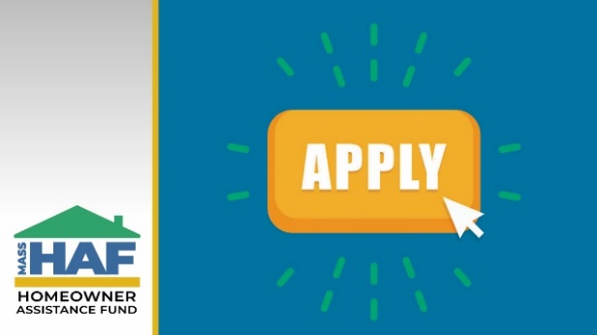
Mass HAF has provided $13.8M in assistance to help Mass homeowners stay in their homes. Mass HAF is still accepting applications. Visit www.massmortgagehelp.org to learn more.  #HomeownerAssitanceFund #mortgagehelp #mortgagerelief #mortgageassistance | 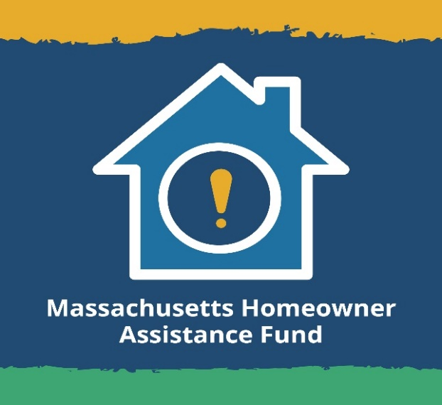
Do you and your family need relief from overdue mortgage payments? Complete a short online screener to see if you qualify for Mass HAF at www.massmortgagehelp.org.  #HomeownerAssitanceFund #mortgagehelp #mortgagerelief #mortgageassistance | 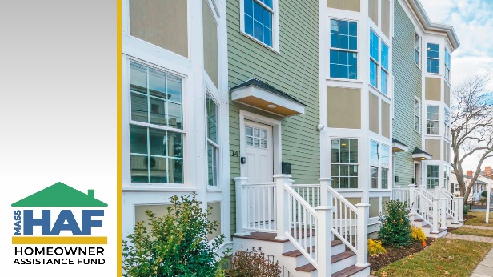
CUSTOMIZABLE: Insert name of organization to promote HAF
Are you looking for mortgage assistance in the __ area? You may qualify for Massachusetts Homeowner Assistance Fund (Mass HAF). Contact us to learn more!  #HomeownerAssitanceFund #mortgagehelp #mortgagerelief #mortgageassistance  www.massmortgagehelp.org | 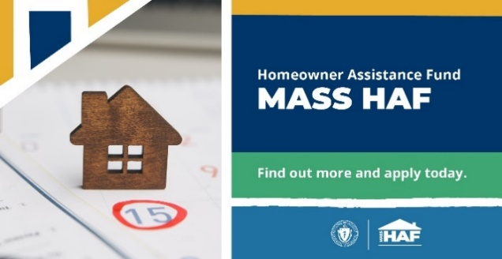
[Name of organization] has information about the Massachusetts Homeowners Assistance Fund. (Mass HAF) – call or visit us to learn more!  #HomeownerAssitanceFund #mortgagehelp #mortgagerelief #mortgageassistance  www.massmortgagehelp.org | 