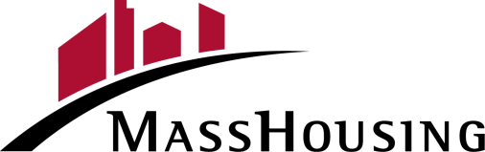

MASSHOUSING REHAB/REPAIR LOAN
LETTER OF COMPLETION

MassHousing Loan Number:
Borrower Name:
Property Address:

The rehabilitation construction and/or repair or improvements to the above-mentioned property have been completed in a workmanlike manner to my/our satisfaction.
I/We certify that:
- The loan proceeds have been spent only on eligible property rehabilitation/repair/improvements.
- The property rehabilitation/repair/improvements have been completed in accordance with the work estimate.
- I am satisfied with the work.

I/We request that the final inspection by the inspector and the final release of funds from the Escrow Account be made to me/us and the contractor after you receive an acceptable Final Inspection Report*

_____________________________________________ _______________________
Borrower Signature Date

_____________________________________________ _______________________
Borrower Signature Date

This request also directs you to properly distribute any funds remaining in the Escrow Account that represent the balance of the Rehab/Repair Costs, Contingency Reserve, inspection fees and other miscellaneous fees that were not used.

I, Escrow Agent (Lender or Local Rehab Agency (LRA)), confirm that all work has been completed per contract with contractor and to the satisfaction of Borrower(s). Upon final disbursement, and all parties are paid in full, any funds remaining in the escrow account will be sent to MassHousing and will be applied to either Borrower(s) principal or the pool of funds, depending on type of loan. I will upload the Final Completion Certificate* upon receipt to emasshousing.com along with this fully executed Letter of Completion and any backup documents. (LRA will send final documents to the Lender to upload to emasshousing.com).

_____________________________________________ _______________________
Escrow Agent (Lender or LRA) Date

*Renovation Loan requires a 1004D
Get The Lead Out requires a Certificate of Compliance
Septic Repair Loan requires a Certificate of Completion
Home Improvement requires Final Inspection Report

_____________________________________________________________________________________
MassHousing Rehab/Repair Loan Letter of Completion – MassHousing -Home Ownership 3/2024

